PROF. KRISHNA DHIR
University of Hawaiʽi at Hilo, Hilo, Hawaiʽi
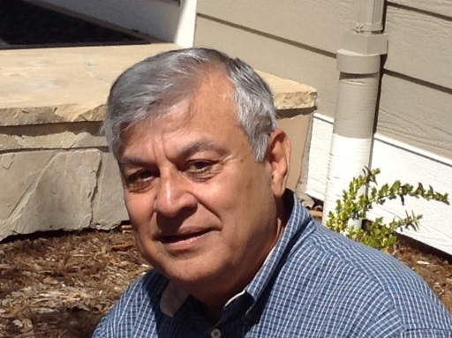
KRISHNA S. DHIR is Professor of Management Science and former Dean of the College of Business and Economics at the University of Hawaii at Hilo, in USA. Also, he is Henry Gund Professor of Management Emeritus at Berry College in Mount Berry, Georgia, USA, where, too, he was Dean of the Campbell School of Business. Prior to that, at The Pennsylvania State University at Harrisburg, he held the endowed S.B.A. Professorship and served as the Director of the School of Business Administration. He steered the latter two institutions to their respective Initial Accreditation by the AACSB International. He has also led the University of Hawaii at Hilo through its Re-accreditation and served as an AACSB-appointed Mentor on initial accreditation to the Missouri University of Science and Technology. Dr. Dhir has advised a number of universities in Australia, Hungary, India, Malaysia, Switzerland, and the United Kingdom, on matters of accreditation, continuous quality improvement, and enhanced student learning. He has also served as the Head of the Department of Business Administration at The Citadel: The Military College of South Carolina. He has taught at the Medical University of South Carolina; University of Colorado in Boulder; University of Denver; and University of Hawai’i at Manoa. Dr. Dhir has over 13 years of cumulative corporate experience, as a Vice President at BioStar Medical Products Inc, in Boulder, Colorado, developing diagnostic products; an executive of CIBA-GEIGY AG (now Novartis) in Basle, Switzerland, in its Medical Department; and a pilot plant engineer with Borg-Warner Chemicals' International Division in Parkersburg, West Virginia, developing high-impact ABS plastics.

