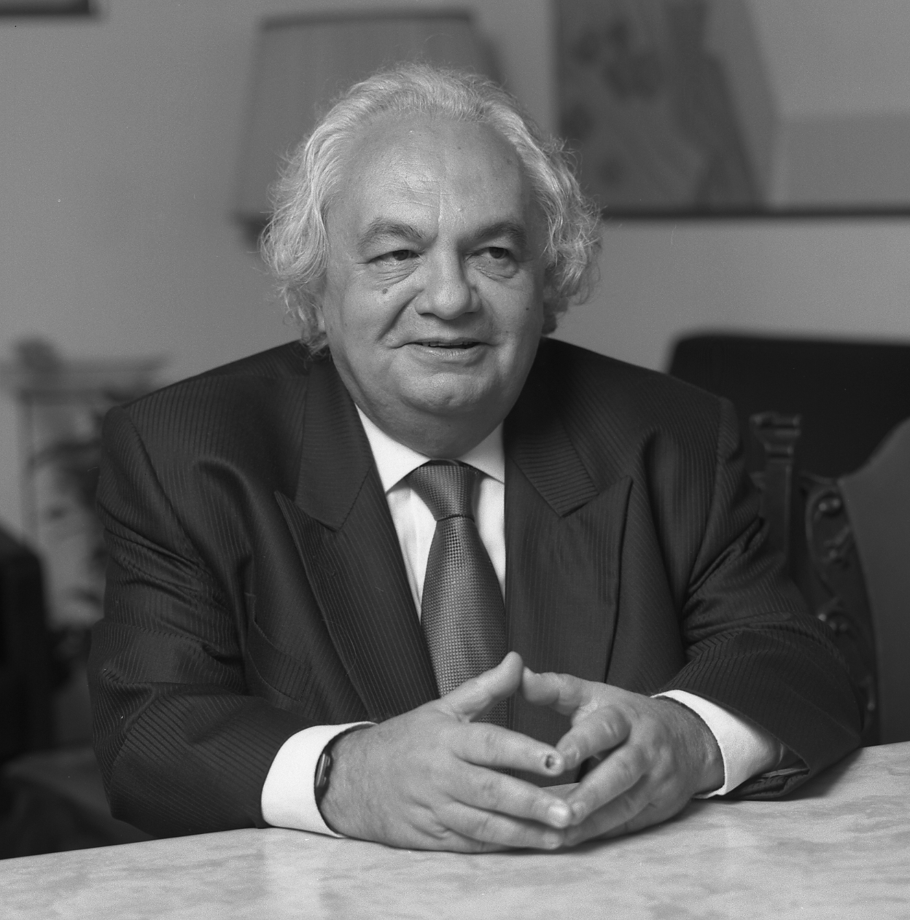

NICOLESCU Basarab
Middle Initial: E.
Current Position: Professor
University name: Babeş-Bolyai University, Cluj-Napoca, Romania
Address: 19 Villa Curial, 75019 Paris, France
Phone: +33603843279
Email: basarab.nicolescu@gmail.com

Education
Year Ph.D.: 1972 University Paris 6 „Pierre et Marie Curie”, Paris, France
Year M.S. : 1965 University of Bucharest, Faculty of Phyiscs, Bucharest, Romania

Employment
1965-1968 Assistant Professor, University of Bucharest, Faculty of Phyiscs, Bucharest, Romania
1968-1969 Grant of the French Government, University Paris 6
1969-1970 Grant "Joliot-Curie" of the Commissariat of Atomic Energy, University Paris 6
1970-2008 National Centre of Scientific Research - Centre National de la Recherche Scientifique (CNRS): Nuclear Physics Institute, Division Theoretical Physics, Orsay and, later, at Laboratory of Nuclear Physics and High Energies, University Paris VI
2008: Retired from CNRS
2006-till now: Associate Professor at Babeş-Bolyai University, Faculty of European Studies, Cluj-Napoca, Romania

Areas of Research Interest

- Topic 1: Quantum physics – Elementary Particle Physics
- Topic 2: Transdisciplinarity
- Topic 3: Philosophy

Awards
1959 Gold Medal at the International Mathematics Olympiad, Brasov, Romania
1986 Silver Medal of the French Academy
1987 Romanian-American Academy Award
1992 Benjamin Franklin Award for Best History Book, USA
2007 "Inter-Balkan Cultural Association - Rigas' Charta" Award, Athens, Greece
2014 International Society for Universal Dialogue (ISUD) Honorary Award
2014 The Academy of Transdisciplinary Learning and Advanced Studies (ATLAS) Gold Medal of Honor, Texas, USA
Doctor Honoris Causa of Veracruzana University (Mexico), „Al. I. Cuza” University (Iaşi, Romania), Technical University (Cluj-Napoca, Romania), University of Craiova (Romania), “Lucian Blaga” University (Sibiu, Romania), University "Vasile Goldis" (Arad, Romania), ”George Bacovia” University (Bacau, Romania) Petroleum-Gaz University (Ploiesti, Romania) and University of the West (Timisoara, Romania).
Member of the Romanian Academy.

Administrative Roles
1981-1994 Member of the Council of the Theoretical Physics Division of the Institute of Nuclear Physics, Orsay, France
1980-1988 Member of the Scientific Council of the Institute of Nuclear Physics, Orsay, France
1990 -1999 Member of the Scientific Council of UER 54 of the University Paris 6 and member of the Committee of Specialists of University Paris 6.

Significant Publications (up to ten)

The Hidden Third, Quantum Prose Publishing, New York, 2016

From Modernity to Cosmodernity - Science, Culture and Spirituality, State University of New York (SUNY) Press, New York, 2014

Transdisciplinarity - Theory and Practice, Hampton Press, Cresskill, New Jersey, 2008.

Manifesto of Transdisciplinarity, State University of New York (SUNY) Press, New York, 2002

Science, Meaning and Evolution - The Cosmology of Jacob Boehme, Parabola Books, New York, 1991

Funded Research Projects
- Government Grants
No one

- Industry Grants
No one

Teaching

2006-2012 Course „Transdisciplinarity, University Babeş-Bolyai, Cluj-Napoca, Romania.
1996-2002 | Course « Quantum Physics for Non-physicists", Center RANDA and University Raimond Llull, Barcelona, Spain.
1984-1985 | Course « Fields and Particles », University Paris 6, France.
1977-1978 | Course « Theoretical Physics », University Paris 11, France.
1975-1976 | Course « Introduction to the Study of Elementary Particles », C4 Particles and Fields, University Paris 6, France.
1973-1974 | Research Course "Hadron Interactions at High Energy", University of Strasbourg, France.
1972-1973 | Research Course "Phenomenology of Strong Interactions", University of Strasbourg, France.
1971-1972 | Course "Collision Theory", University Paris 6, France.
1967-1968 | Research Course "Theory of Regge Poles", University of Bucharest, Romania.
1965-1968 | Course "Classical Electrodynamics", University of Bucharest, Romania.

Student Supervision

Doctoral Students – 15 PhD students, University Babeş-Bolyai, Cluj-Napoca, Romania. 14 students already passed their thesis.

Examination Committees
Many committees in physics and in transdisciplinarity

Professional and Editorial Activities
Director of the « Transdisciplinarity » series, Rocher Publishing House, Monaco, “Romanians of Paris” series ("Les Roumains de Paris"), Oxus Publishing House, Paris, "Science and Religion" and „Science, Spirituality, Society” series (Curtea Veche, Publishing House, Bucharest). Editor-in-Chief of "Transdisciplinary Journal of Engineering&Science", USA, Transdisciplinarity in Science and Religion and Transdisciplinary Studies – Science, Spirituality, Society, Curtea Veche Publishing House, Bucharest.

Consulting
Nothing

Major Presentations (up to five)

1 . ATLAS International Transdisciplinary - Transnational - Transcultural (T3) Conference "Education / Technological Singularity / Technological Innovation" , Xi'an Jiaotong - Liverpool University, Suzhou, China, 30 May 2016.
- Technological Singularity – The Dark Side (key-note talk)
2. International Congress "Lights of the World", Palace of Parliament, Bucharest, Romania, 30 October 2015
- Light in Science, Culture, Society, and Spirituality - The Transdisciplinary Unifier
3. Symposium on transdisciplinarity in postgraduate education "Rethinking postgraduate higher education from transdisciplinary perspectives", Middlesex University, London, UK, 22 July 2015
- The need for transdisciplinarity in higher education
4. ISIS Summit Vienna "The Information Society at the Crossroads", Vienna University of Technology, Vienna, Austria, 5 June 2015
- How Can We Enter in Dialog? Transdisciplinary Methodology of the Dialog Between People, Cultures, and Spirituality - Natural Information and Spiritual Information
5. Quinto congreso internacional de ciencias sociales, humanidades y salud - "Identidad, bienestar y sustentabilidad", Aula Magna, AUEM, University of Toluca, Mexico, 13 November 2014
- La necesidad de la transdisciplinariedad para enfrentar los desafíos del siglo XXI​ ​(opening talk​)​

