PROF. MARKKU KUULA
Aalto University School of Business, Finnland
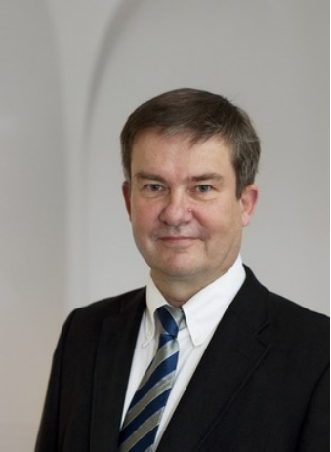
Markku Kuula is professor of logistics and head of the department of information and service economy at Aalto University School of Business. He earned his Ph.D. (Econ) degree in 1993 from the Helsinki School of Economics. Since that he acted three years as senior researcher and associate professor at Helsinki School of Economics in management science. After that he was 16 years the CIO of Helsinki School of Economics. Markku Kuula has been president of the Finnish Operations Research Society (FORS) in years 1992-1993 and 2012 and president of the European Decision Science Institute (EDSI) in year 2014. He is associate editor of Decision Sciences Journal since 2014. He is also council member of Heureka Science Centre in Vantaa. Markku Kuula has published articles in several international refereed operations research and operations management journals. His current research interests have related to industrial benchmarking, sustainability, service operations, and multi criteria optimization.

