IVÁN, GYÖRGY JÓZSEF
Managing Director at Hödlmayr Hungária Logistics Kft
H-9024 Győr, Szérüskert u. 2-10
Tel.: 0036-96-510-200

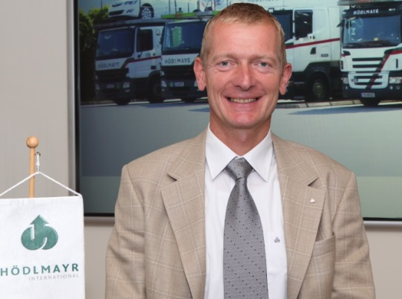
Currently, György Iván is Managing Director at Hödlmayr Hungária Logistics Kft. Born in Hungary, earned Bachelor Mechanical engineer and Bachelor Economic engineer degrees from University of Miskolc, Hungary.
He finished the Post graduate management at University of Economy Vienna.
Mr. Iván worked at the biggest Hungarian vehicle factories RÁBA Hungarian Wagon and Machine Factory Ltd. and Opel Hungary Manufacturing Ltd and since 1994 he has been working Hödlmayr Hungária Logistics Kft.
Almost 20 years (since 1998) he is a Managing Director at the company.
This company is a subsidiary an Austrian vehicle transport and logistics company. Hödlmayr international is a leading supplier of own transport fleets for vehicle logistics throughout Europe and offers a complete releasing agent package in the plant logistics area.
Hödlmayr Hungária Logistics Kft is the first logistics company in the region, which won the national quality award from EFOM in 2004.
Mr. Iván member of many charity organization e.g. Alliance the Lions Club and he is Honorary Consul of Austria.
His strengths are automotive experiences, motivation force, positive leadership, coach managerial style.

