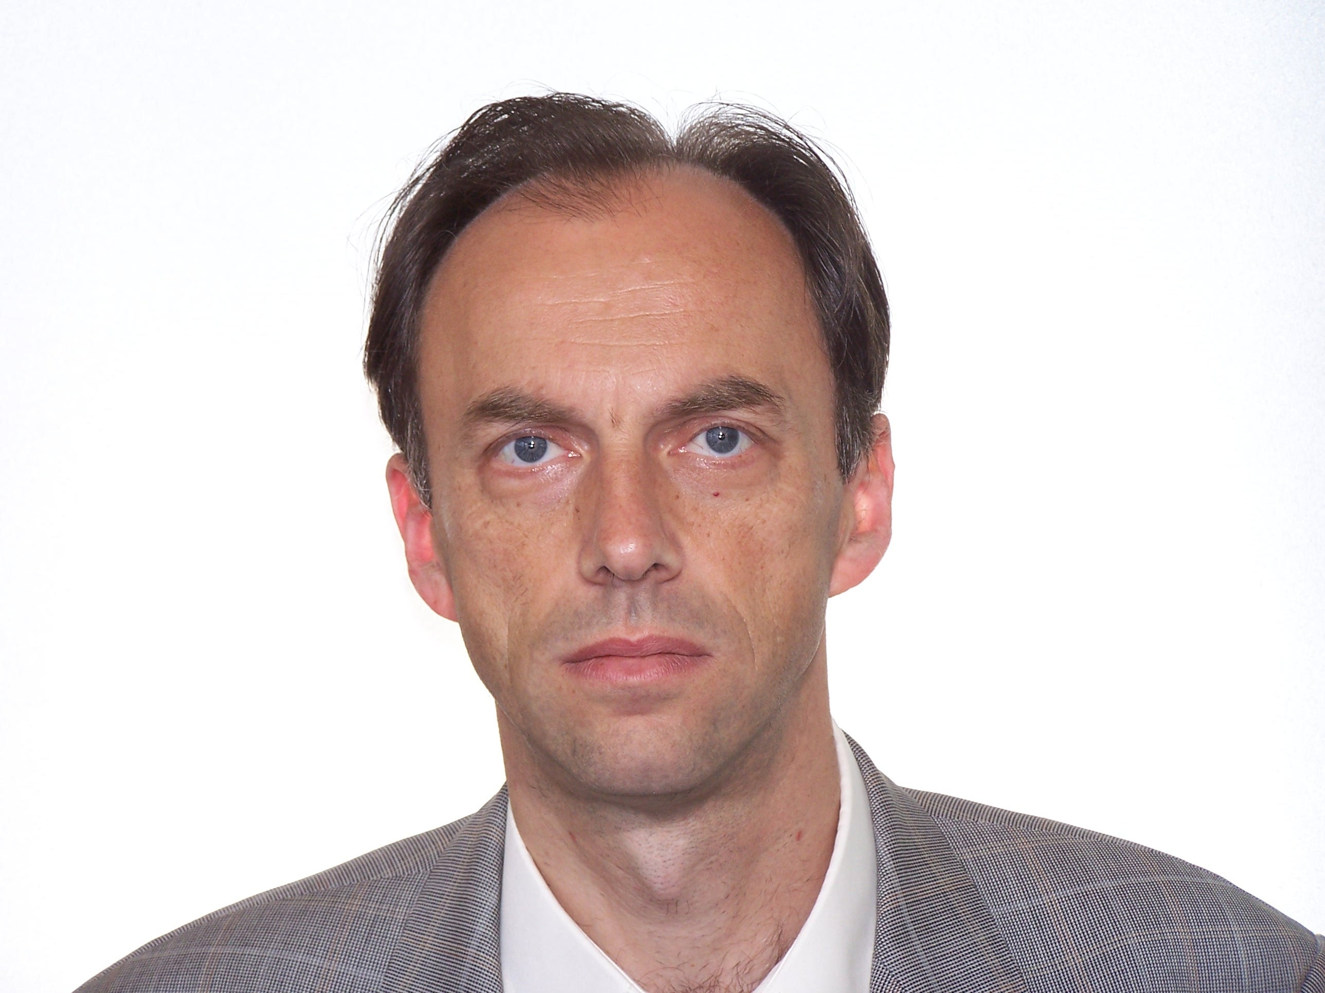

ČAUŠEVIĆ, FIKRET

Professor of Economics and International Finance
School of Economics and Business, University of Sarajevo
Trg oslobodjenja – A.Izetbegovic 1, 71000, Sarajevo, Bosnia and Herzegovina
Phone: +387-33-275-910; fikret.causevic@efsa.unsa.ba

Education

2003 PhD Degree, University of Sarajevo, School of Economics and Business
1995 MSc Degree, University of Sarajevo, School of Economics and Business
1987 BSc Degree, Universtiy of Sarajevo, School of Economics and Business

Employment

Since 2012 Full Professor, School of Economics and Business, University of Sarajevo
2008-2012 Associate Professor, School of Economics and Business, University of Sarajevo
2004 -2008 Assistant Professor, School of Economics and Business, University of Sarajevo
1995-2007 Senior Researcher, Economics Institute Sarajevo, University of Sarajevo
1989-1992 Researcher, Economics Institute Sarajevo, University of Sarajevo

Areas of Research Interest

- Financial Economics
- Macroeconomics
- Economic growth
- Monetary and fiscal policy

Awards

2011-2012 Alpha Bank Visiting Fellow, St Antony’s College, SEESOX, University of Oxford
2002; 2005; 2006; 2007; 2010 – South-East Europe Faculty Development Programme Visiting Fellow, London School of Economics and Political Science, London (Funded by DFID, LSE and Open Society Fund New York)

Administrative Roles

  - Member of the Governing Board of the Central Bank of Bosnia and Herzegovina
1999-2007 Deputy Director, Economics Institute Sarajevo, University of Sarajevo

Significant Publications
1.Financial Globalization, Economic Growth, and (In)Equality: 1990-2014 – Forthcoming, Palgrave Macmillan, London (expected date of publishing – end of January 2017) (book)
2. Globalization, Southeast Europe, and the World Economy, Routledge Studies in the European Economy, Routledge, London-New York, 2015. (book) (Scopus Content – List of Books)
3. The Global Crisis of 2008 and Keynes’s General Theory, SpringerBriefs in Economics, Springer, Cham-Heidelberg-New York, 2014. (book)
4. Principles of Economics – Volume I: Principles of Microeconomics, School of Economics and Busines, University of Sarajevo, Sarajevo, 2015. (textbook)
5. Principles of Economics – Volume II: Principles of Macroeconomics, School of Economics and Business, University of Sarajevo, Sarajevo, 2015. (textbook)
6. „The Political Economy of Economic Liberalization and Competitiveness in Bosnia and Herzegovina”, in: Margo Thomas and V.Bojicic-Dzelilovic (eds), Public Policy Making in the Western Balkans, Springer, Dordrecht, 2014. (chapter V) (Scopus Content – List of Books)
7. „What type of fiscal policy is needed for the Western Balkans during the crisis”, Southeast European and Black Sea Studies, Vol. 12., Issue 2, Taylor&Francis, pp. 357-372. (paper - SSCI)

Funded ResearchProjects

1. “Improving the Process of Legislative Reforms in the Western Balkans”, OECD Investment Compact for South East Europe, Institute of Economics Belgrade, German Organization for Technical Cooperation (GTZ), Belgrade, 2010 (Co-author with Slavica Penev and Andreja Marušić)
2. Key long term local expert – project financed by the European Union/European Commission in Bosnia and Herzegovina: „Technical Support to Economic Policy Planning Unit of the Council of Ministers of Bosnia and Herzegovina“, July 2006 - March 2007. (team leader Joseph Poeschl – WIIW)

3. Program of Technical Support to Local Economic Policy Research Organisations – financed by the United States Agency for International Development in cooperation with the Urban Institute from Washington (Coordinated by Dr. Raymond Struyk) – April 2004 - September 2006: studies published during the project:

„Money Market Development in Bosnia and Herzegovina“ (June – December 2004) (financed by USAID) (Author: Fikret Čaušević)
“Trade Policy and Trade Balance in Bosnia and Herzegovina” (March-September 2005) (financed by USAID)
(Author: Fikret Čaušević)
“Metal Sector Development in Bosnia and Herzegovina” (October 2005-June 2006) (financed by USAID)
(Co-authors: Fikret Čaušević and Anto Domazet)

4. Key long term local expert – projects financed by the European Union/European Commission in Bosnia and Herzegovina: „Vertical Review of the Economic Sector in Bosnia and Herzegovina“, April-September 2004.

Teaching

University of Sarajevo Principles of Economics (undergraduate)
University of Sarajevo Financial System of the European Union (undergraduate)
University of Sarajevo Advanced International Finance (II) - (graduate level)
University of Sarajevo History and Philosphy of Economic Thought (PhD level)

Student Supervision

Master's Students 12

Doctoral Students 4

Professional and Editorial Activities
Member of the Editorial Board of the Southeast European Journal of Economics and Business, School of Economics and Business, University of Sarajevo (2006-2009)

Consulting

BH Telecom dd Sarajevo (2001-2002; 2004)
HT Mostar dd Mostar (2001-2002)

Major Presentations

“The Global Crisis, Keynes’s Solutions & Small Open Economies”, A special lecture at CERGE-EI, Prague, 19 May 2015.
“East Forum Berlin”, Berlin, 9-10 April, 2014; List of speakers at East Forum Berlin since 2013 at: https://en.wikipedia.org/wiki/East_forum_Berlin (Title of presentation: “Financial Innovation for the Western Balkan countries as a source of financing infrastructural projects: A proposal for establishing the EU-Guarantee Fund for the Western Balkans and for the issuance of Euro-Balkan Bonds”)
„Economic Liberalization and Small Open Economies: The Case of Western Balkan Countries“, Visiting Fellows' Workshop, European Studies Centre, St Antony's College, University of Oxford, 15 February 2012.
„Economic Liberalization of the Western Balkans“, LSEE Visiting Speaker Programme, London School of Economics, European Institute, London, 24 January 2012.
„Investment Obstacles to a Stronger Economic Growth“, Bank of Albania-SEESOX High Level Workshop, St Antony's College, University of Oxford, 2 December 2011.

